**Import csv file using apex visualforce**

Normally we use Apex data loader to import data in salesforce from CSV file. Now a days some other tools are also available to load data in salesforce like Jitterbit data loader. But sometime there is requirement when end users do not want to use Apex Data loader. They want some custom page to load data in salesforce. Then in that case we can use custom code to load data in salesforce from csv file.

Also sometime using single CSV file we want to load data in multiple objects. Then in that case we can not use data loader to load data. In that case we can use custom code to load data in salesforce.

In the example below we are loading data from CSV file for account objects.

First of all we need CSV file format. [Click here](http://www.sfdcpoint.com/wp-content/uploads/2014/03/Account-CSV-Import-Format.csv) to download CSV file. You can modify CSV file to insert or import account records. CSV file attached has following format:

[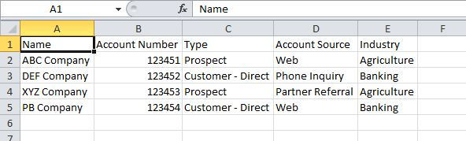](http://www.sfdcpoint.com/wp-content/uploads/2014/03/Import-CSV-excel-file.jpg)

Now we need to write code in Apex and visualforce which will  read csv file and insert records in account object.

Click on choose file, then select csv file and then click on ‘Import Account’ button. All records from csv file will be inserted on account records. I have commented insert account line. So this example will only show account records on visualforce page. You can uncomment insert account list line in below code if you want to insert account list.

[Click for demo](http://demopoint-developer-edition.ap1.force.com/importDataFromCSV)

[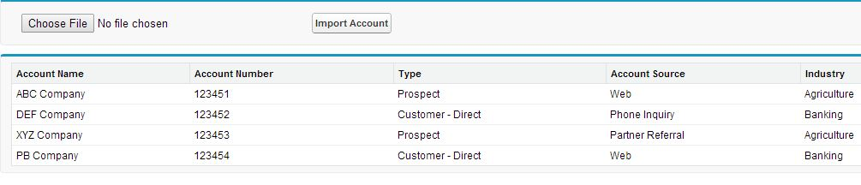](http://www.sfdcpoint.com/wp-content/uploads/2014/03/import-CSV-file-page.jpg)

**Visualforce Page:**

|  |  |
| --- | --- |
| 1  2  3  4  5  6  7  8  9  10  11  12  13  14  15  16  17  18  19  20 | <apex:page controller="importDataFromCSVController">      <apex:form >          <apex:pagemessages />          <apex:pageBlock >              <apex:pageBlockSection columns="4">                    <apex:inputFile value="{!csvFileBody}"  filename="{!csvAsString}"/>                    <apex:commandButton value="Import Account" action="{!importCSVFile}"/>              </apex:pageBlockSection>          </apex:pageBlock>          <apex:pageBlock >             <apex:pageblocktable value="{!accList}" var="acc">                <apex:column value="{!acc.name}" />                <apex:column value="{!acc.AccountNumber}" />                <apex:column value="{!acc.Type}" />                <apex:column value="{!acc.Accountsource}" />                <apex:column value="{!acc.Industry }" />          </apex:pageblocktable>       </apex:pageBlock>     </apex:form>  </apex:page> |

**Apex Code:**

|  |  |
| --- | --- |
| 1  2  3  4  5  6  7  8  9  10  11  12  13  14  15  16  17  18  19  20  21  22  23  24  25  26  27  28  29  30  31  32  33  34 | public class importDataFromCSVController {  public Blob csvFileBody{get;set;}  public string csvAsString{get;set;}  public String[] csvFileLines{get;set;}  public List<account> acclist{get;set;}    public importDataFromCSVController(){      csvFileLines = new String[]{};      acclist = New List<Account>();    }      public void importCSVFile(){         try{             csvAsString = csvFileBody.toString();             csvFileLines = csvAsString.split('\n');               for(Integer i=1;i<csvFileLines.size();i++){                 Account accObj = new Account() ;                 string[] csvRecordData = csvFileLines[i].split(',');                 accObj.name = csvRecordData[0] ;                 accObj.accountnumber = csvRecordData[1];                 accObj.Type = csvRecordData[2];                 accObj.AccountSource = csvRecordData[3];                 accObj.Industry = csvRecordData[4];                 acclist.add(accObj);             }          //insert acclist;          }          catch (Exception e)          {              ApexPages.Message errorMessage = new ApexPages.Message(ApexPages.severity.ERROR,'An error has occured while importin data Please make sure input csv file is correct');              ApexPages.addMessage(errorMessage);          }    }  } |